  - Atividade 7:
Let’s review what is around our neighborhood!!! Can you remember some of these places:
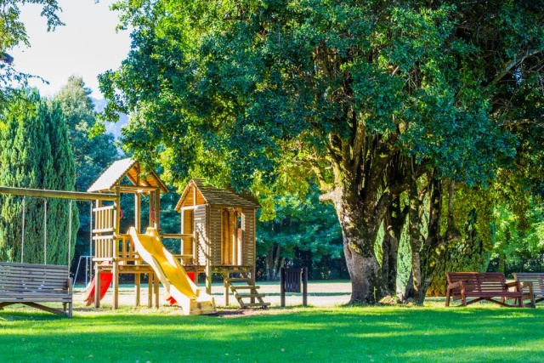park
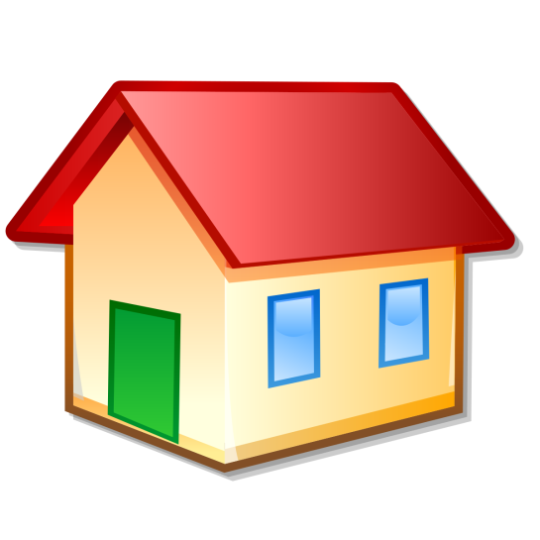house / home

Além desses, apredemos outrous lugares da cidade. Então, emu ma folha desenho esses lugares:
- Supermarket
- Pet shop
- Shopping mall / Mall
- Club

Enjoy your activity.
Kisses,
Teacher Manu e Fer

